Spotlight On Business

In the spot light - Atkins

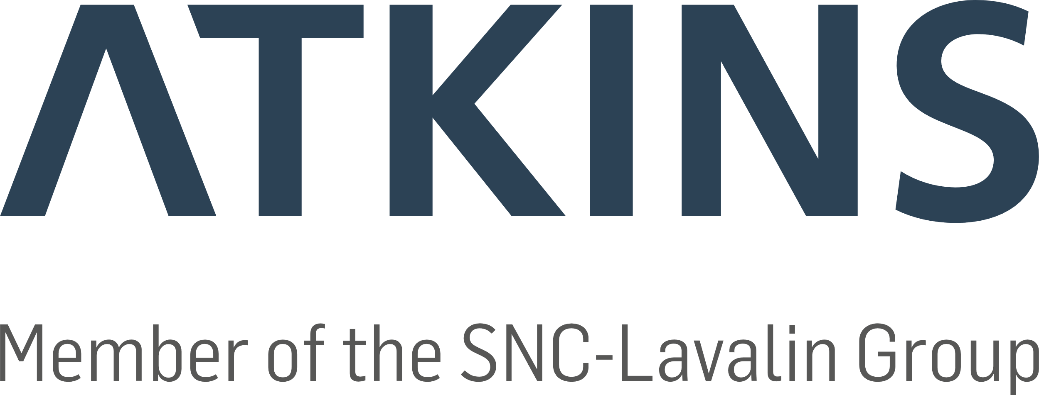
Atkins, a member of the SNC-Lavalin Group, is one of the world’s most respected design, engineering and project management consultancies.

This month we will be shinning a light on another of Wiltshire’s local business.
Giving you an insight into how diverse and exciting the world of work is in our county. You will be surprised what happens behind the doors and gates of businesses that you didn’t even know existed. It may even inspire you to consider a career in a sector you’d never even thought about.
In the spotlight this month is Atkins I have been getting the lowdown from Ryan Beale Atkins Civil Engineering Technician and apprentice based in Trowbridge.
So, Ryan, tell me a bit about Atkins, what type of business are you, what do you do?

Atkins, a member of the SNC-Lavalin Group, are an international design, engineering and project management consultancy. Locally staff from our Trowbridge office work on behalf of Wiltshire Council to help maintain their assets, their roads and bridges, and look to design and implement new ones.

How many people work here, and what type of roles are there?
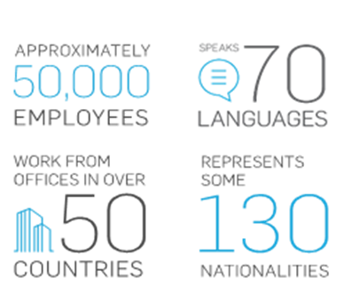

SNC-Lavalin have approximately 50,000 employees worldwide, around 12,000 of those are in Europe, 16,000 in Americas. Locally we have many Engineers, in a range of areas, Transport Planners, Architects, Landscape Designers and Project Managers.

Do you recruit apprentices, and what type, and what about work experience?
We do! I am one! Atkins have opportunities as Higher, Advanced and Degree apprentice levels, in a whole range of roles. I’m a big fan of apprenticeships, earning while you learn is great for so many. We also have Work Experience, Graduate, Summer Placement and Industrial Placement roles at Atkins.
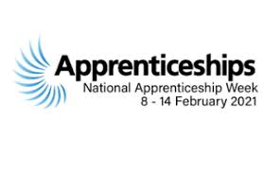

How long have you worked here and what does your role involve?
I have now worked at Atkins for over 5 years. My role has changed over that period, working in a range of areas including Highway Maintenance schemes in Wiltshire to Bridges and Structures in Hampshire. I currently work in our Highways Major Projects team working on large scale major highway schemes in Wiltshire!

What’s it like to work here?
It’s a great environment to learn. As someone who is always eager to know more there are so many experienced colleagues around you, this helps as an apprentice but also benefits colleague at any level. Why don’t you take a look for yourself https://www.atkinsglobal.com/en-GB/about-the-group

If I wanted to work for Atkins, how would you recommend I went about it?
I always point people towards our website where we have vacancies posted for all areas and all sectors. If you are interested in work experience or placements, or have any questions relating to Atkins you contact our local office team by email; WiltshireSTEM@atkinsglobal.com.

