Spotlight On Business

Giving you an insight into how diverse and exciting the world of work is in our county. You will be surprised what happens behind the doors and gates of businesses that you didn’t even know existed. It may even inspire you to consider a career in a sector you’d never even thought about.
In the Spotlight this month is H5 Adventure.
www.h5adventure.com
H5 Adventure deliver team & outdoor activities for schools, groups, and corporate clients which include:
- Multi Activity Residentials
- The Duke of Edinburgh Award Expeditions
- Team Building Days
H5 are based in Royal Wootton Basset, however, work with clients from South Wales, along the M4 to the outskirts of London, and as far south as Dartmoor and North towards Birmingham

We have been chatting to Rikki, an instructor who has worked for H5 Adeventure for 6 years. Rikki started as an assistant instructor, and now directs the entire menu of courses for H5, from team building days to residentials with up to 100 young people.
How many people work at H5, and what type of roles are there?
All our instructors are self employed and can work anything from just 1 day a year, to 5 months, depending on their qualifications, location of course and how much they wish to work. The flexibility is what they enjoy.
Do you recruit apprentices, and what type, and what about work experience?
No, but we do offer opportunities for young people to be an assistant on courses. From the odd week here and there on residentials, to a complete 4 week program at Marlborough College’s Summer School.
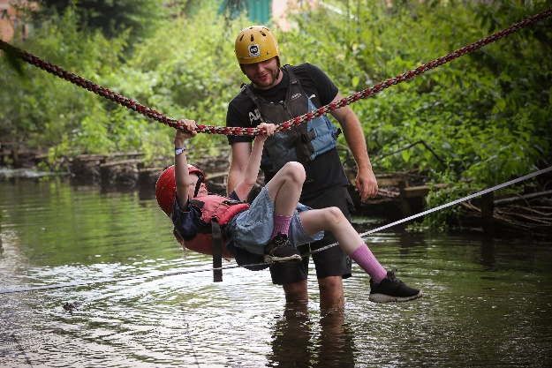
What’s it like to work here?
Hard work. Sometimes, we work long hours, in wet conditions, but this always leaves us with a sense of achievement. Working with a strong team creates a happy working environment, which always brings positive results. I wouldn’t change it for a minute!
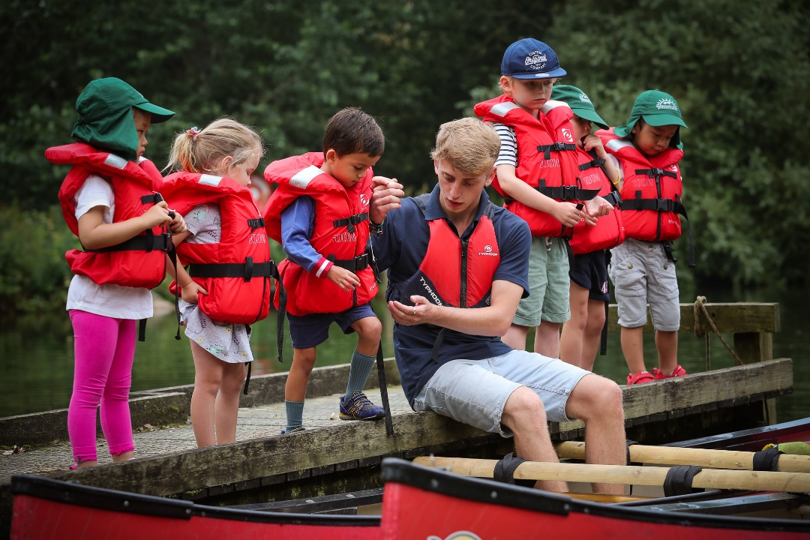
If I wanted to work for H5 Adventure, how would you recommend I went about.
We advertise for new instructors every year in late summer, but do welcome others getting in touch. We have many fully qualified roles available, but also offer opportunities for younger, new to the industry, positive, likeminded people. We offer a few places every year on some courses for individuals with lower qualifications to see if this industry would suit them. We recruit between 5 to 10 self-employed instructors each year to join our database of instructors. We require instructors who can deliver rock climbing and paddle sport activities, but something as simple as a walking qualification is a good start. All our instructors need to be 18 and over, and require a DBS Certificate, which we can assist with.
And finally, do you have a fun or interesting fact about H5 Adventure clients:
We have met England Rugby World Cup Winners, and Ex England Footballers, all, we can whole heartedly say, lovely, genuine people.
@H5Adventure
H5 Adventure

